# Fop Lab task #5

## Name: Muhammad Usman Bhutto

## Cms id: 453891

## Section: B

**Lab task 1:**

#include<iostream>

using namespace std;

int main()

{

int x=1;

do

{

cout<<"enter a number:";

cin>>x;

}

while(x>0);

return 0;

}

**Output:**

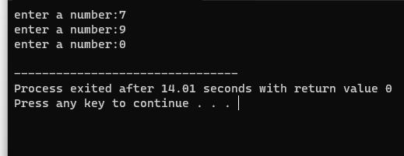

**Lab task 2:**

#include <iostream>

using namespace std;

int main() {

char choice;

do {

double num1, num2;

char operation;

cout << "Enter the first number: ";

cin >> num1;

cout << "Enter an operation (+, -, *, /): ";

cin >> operation;

cout << "Enter the second number: ";

cin >> num2;

double result;

switch (operation) {

case '+':

result = num1 + num2;

break;

case '-':

result = num1 - num2;

break;

case '*':

result = num1 * num2;

break;

case '/':

if (num2 != 0) {

result = num1 / num2;

} else {

cout << "Error: Division by zero is not allowed." << endl;

continue;

}

break;

default:

cout << "Invalid operation. Please enter +, -, *, or /." << endl;

continue;

}

cout << "Result: " << num1 << " " << operation << " " << num2 << " = " << result << endl;

cout << "Do you want to perform another calculation? (y/n): ";

cin >> choice;

} while (choice == 'y' || choice == 'Y');

cout << "Calculator terminated. Thank you!" <<endl;

return 0;

}

**Output:**

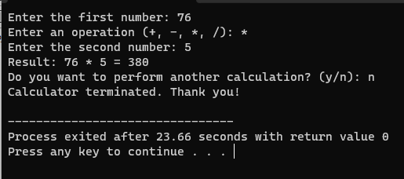

**Lab task 3(a):**

//Part (a)

#include <iostream>

using namespace std;

int main() {

int num = 2;

int sum = 0;

while (num <= 100) {

sum += num;

num += 2;

}

cout << "The sum of even numbers between 2 and 100 is: " << sum <<endl;

return 0;

}

**Output:**

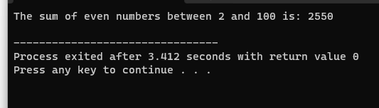

**Lab task 3(b):**

//part(b)

#include <iostream>

using namespace std;

int main() {

int num = 1;

int sum = 0;

while (num <= 100) {

sum += num * num;

num++;

}

cout << "The sum of squares between 1 and 100 is: " << sum <<endl;

return 0;

}

**Output:**

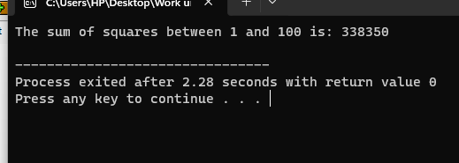

**Lab task 4(a):**

// part(a)

#include <iostream>

#include <cmath>

using namespace std;

int main() {

int exponent = 0;

while (exponent <= 20) {

long long result =pow(2, exponent);

cout << "2^" << exponent << " = " << result <<endl;

exponent++;

}

return 0;

}

**Output:**

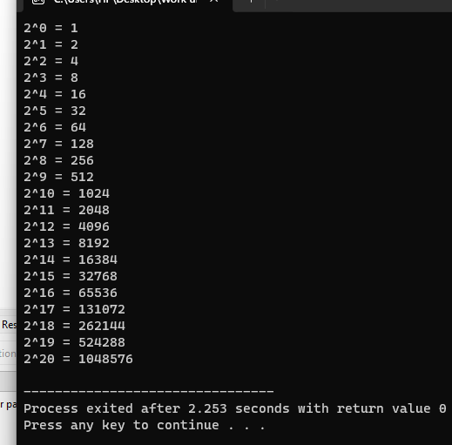

**Lab task 4(b):**

//part(b)

#include <iostream>

using namespace std;

int main() {

int a, b;

cout << "Enter the values of a and b: ";

cin >> a >> b;

int sum = 0;

int current = a;

do {

if (current % 2 != 0) {

sum += current;

}

current++;

} while (current <= b);

cout << "The sum of all odd numbers between " << a << " and " << b << " is " << sum <<endl;

return 0;

}

**Output:**

